# Model 1

4 convolution layers with 16, 32,64 and 128 filters respectively and added dropouts of 20% on each layer. One dense layer with 6 output nodes.

Number of Epochs =250

Training Accuracy: 0.9263301491737366

Testing Accuracy: 0.875

precision recall f1-score support

Bronchiectasis 0.00 0.00 0.00 3

Bronchiolitis 0.00 0.00 0.00 3

COPD 0.90 1.00 0.95 159

Healthy 0.00 0.00 0.00 7

Pneumonia 0.40 0.29 0.33 7

URTI 0.00 0.00 0.00 5

accuracy 0.88 184

macro avg 0.22 0.21 0.21 184

weighted avg 0.80 0.88 0.83 184

Confusion Matrix:

[[ 0 0 3 0 0 0]

[ 0 0 3 0 0 0]

[ 0 0 159 0 0 0]

[ 0 0 4 0 1 2]

[ 0 0 5 0 2 0]

[ 0 0 2 1 2 0]

# Model 2

4 convolution layers with 16, 32,64 and 128 filters respectively and added dropouts of 20% on each layer. One dense layer with 6 output nodes.

Number of Epochs =125

Training Accuracy: 0.9249659180641174

Testing Accuracy: 0.8804348111152649

precision recall f1-score support

Bronchiectasis 0.67 0.67 0.67 3

Bronchiolitis 0.33 0.33 0.33 3

COPD 0.96 0.96 0.96 159

Healthy 0.00 0.00 0.00 7

Pneumonia 0.50 0.71 0.59 7

URTI 0.17 0.20 0.18 5

accuracy 0.88 184

macro avg 0.44 0.48 0.45 184

weighted avg 0.87 0.88 0.87 184

Confusion Matrix

[[ 2 0 1 0 0 0]

[ 0 1 1 1 0 0]

[ 1 0 153 1 1 3]

[ 0 1 3 0 1 2]

[ 0 0 2 0 5 0]

[ 0 1 0 0 3 1]]

# Model 3

3 convolution layers with 16, 32 and 64 filters respectively and added dropouts of 20% on each layer. One dense layer with 6 output nodes.

Number of Epochs =250

Training Accuracy: 0.9085947871208191

Testing Accuracy: 0.885869562625885

precision recall f1-score support

Bronchiectasis 1.00 0.67 0.80 3

Bronchiolitis 0.00 0.00 0.00 3

COPD 0.91 0.99 0.95 159

Healthy 0.00 0.00 0.00 7

Pneumonia 0.20 0.14 0.17 7

URTI 0.67 0.40 0.50 5

accuracy 0.89 184

macro avg 0.46 0.37 0.40 184

weighted avg 0.83 0.89 0.85 184

Confusion Matrix:

[[ 2 0 1 0 0 0]

[ 0 0 3 0 0 0]

[ 0 0 158 0 1 0]

[ 0 0 3 0 3 1]

[ 0 0 6 0 1 0]

[ 0 0 3 0 0 2]]

# Model 4

3 convolution layers with 16, 32 and 64 filters respectively and added dropouts of 20% on each layer. One Dense layer with 6 output nodes.

Number of Epochs =150

Training Accuracy: 0.9004092812538147

Testing Accuracy: 0.885869562625885

precision recall f1-score support

Bronchiectasis 0.67 0.67 0.67 3

Bronchiolitis 0.50 0.33 0.40 3

COPD 0.93 0.97 0.95 159

Healthy 0.50 0.29 0.36 7

Pneumonia 0.33 0.43 0.38 7

URTI 0.00 0.00 0.00 5

accuracy 0.89 184

macro avg 0.49 0.45 0.46 184

weighted avg 0.86 0.89 0.87 184

Confusion Matrix

[[ 2 0 1 0 0 0]

[ 0 1 2 0 0 0]

[ 1 0 155 0 3 0]

[ 0 1 2 2 2 0]

[ 0 0 4 0 3 0]

[ 0 0 2 2 1 0]]

# Model 5

4 convolution layers with 16, 32, 64 and 128 filters respectively and added dropouts of 20% on each layer. One dense hidden layer with 32 neurons and one output layer with 6 neurons.

Number of Epochs = 250

Training Accuracy: 0.9345157146453857

Testing Accuracy: 0.875

precision recall f1-score support

Bronchiectasis 0.00 0.00 0.00 3

Bronchiolitis 0.00 0.00 0.00 3

COPD 0.93 0.97 0.95 159

Healthy 0.00 0.00 0.00 7

Pneumonia 0.42 0.71 0.53 7

URTI 0.25 0.20 0.22 5

accuracy 0.88 184

macro avg 0.27 0.31 0.28 184

weighted avg 0.82 0.88 0.85 184

Confusion Matrix:

[[ 0 0 1 0 1 1]

[ 0 0 3 0 0 0]

[ 0 1 155 0 3 0]

[ 0 0 4 0 1 2]

[ 0 0 2 0 5 0]

[ 0 0 2 0 2 1]]

# Model 6

4 convolution layers with 16, 32, 64 and 128 filters respectively and added dropouts of 20% on each layer. One dense hidden layer with 32 neurons and one output layer with 6 neurons.

Number of Epochs = 125

Training Accuracy: 0.9045020341873169

Testing Accuracy: 0.8586956262588501

precision recall f1-score support

Bronchiectasis 0.00 0.00 0.00 3

Bronchiolitis 0.00 0.00 0.00 3

COPD 0.89 0.98 0.93 159

Healthy 0.00 0.00 0.00 7

Pneumonia 0.40 0.29 0.33 7

URTI 0.00 0.00 0.00 5

accuracy 0.86 184

macro avg 0.22 0.21 0.21 184

weighted avg 0.79 0.86 0.82 184

Confusion Matrix

[[ 0 0 3 0 0 0]

[ 0 0 2 0 0 1]

[ 0 0 156 0 1 2]

[ 0 0 5 0 1 1]

[ 0 0 5 0 2 0]

[ 0 0 4 0 1 0]]

# Model 7

4 convolution layers with 16, 32, 64 and 128 filters respectively and added dropouts of 20% on each layer. One dense hidden layer with 64 neurons and one output layer with 6 neurons.

Number of Epochs = 250

Training Accuracy: 0.9154161214828491

Testing Accuracy: 0.8695651888847351

precision recall f1-score support

Bronchiectasis 0.00 0.00 0.00 3

Bronchiolitis 0.00 0.00 0.00 3

COPD 0.88 1.00 0.94 159

Healthy 0.00 0.00 0.00 7

Pneumonia 0.00 0.00 0.00 7

URTI 0.33 0.20 0.25 5

accuracy 0.87 184

macro avg 0.20 0.20 0.20 184

weighted avg 0.77 0.87 0.82 184

Confusion Matrix

[[ 0 0 3 0 0 0]

[ 0 0 3 0 0 0]

[ 0 0 159 0 0 0]

[ 0 0 5 0 0 2]

[ 0 0 7 0 0 0]

[ 0 0 3 1 0 1]]

# Model 8

4 convolution layers with 16, 32, 64 and 128 filters respectively and added dropouts of 20% on each layer. One dense hidden layer with 64 neurons and one output layer with 6 neurons.

Number of Epochs = 125

Training Accuracy: 0.8976807594299316

Testing Accuracy: 0.875

precision recall f1-score support

Bronchiectasis 1.00 0.67 0.80 3

Bronchiolitis 0.33 0.33 0.33 3

COPD 0.90 0.98 0.94 159

Healthy 0.00 0.00 0.00 7

Pneumonia 1.00 0.14 0.25 7

URTI 0.25 0.20 0.22 5

accuracy 0.88 184

macro avg 0.58 0.39 0.42 184

weighted avg 0.85 0.88 0.85 184

Confusion Matrix

[[ 2 0 1 0 0 0]

[ 0 1 1 0 0 1]

[ 0 0 156 1 0 2]

[ 0 1 6 0 0 0]

[ 0 0 6 0 1 0]

[ 0 1 3 0 0 1]]

# Model 9

4 convolution layers with 16, 32, 64 and 128 filters respectively and added dropouts of 20% on each layer. One dense hidden layer with 128 neurons and one output layer with 6 neurons.

Number of Epochs = 250

Training Accuracy: 0.9386084675788879

Testing Accuracy: 0.8913043737411499

precision recall f1-score support

Bronchiectasis 0.50 0.33 0.40 3

Bronchiolitis 0.00 0.00 0.00 3

COPD 0.92 0.99 0.96 159

Healthy 1.00 0.14 0.25 7

Pneumonia 0.50 0.29 0.36 7

URTI 0.40 0.40 0.40 5

accuracy 0.89 184

macro avg 0.55 0.36 0.40 184

weighted avg 0.87 0.89 0.87 184

Confusion Matrix

[[ 1 0 1 0 0 1]

[ 0 0 3 0 0 0]

[ 1 0 158 0 0 0]

[ 0 0 3 1 1 2]

[ 0 0 5 0 2 0]

[ 0 1 1 0 1 2]]

# Model 10

4 convolution layers with 16, 32, 64 and 128 filters respectively and added dropouts of 20% on each layer. One dense hidden layer with 128 neurons and one output layer with 6 neurons.

Number of Epochs = 1

Training Accuracy: 0.8813096880912781

Testing Accuracy: 0.8478260636329651

precision recall f1-score support

Bronchiectasis 0.00 0.00 0.00 3

Bronchiolitis 0.17 0.67 0.27 3

COPD 0.90 0.97 0.93 159

Healthy 0.00 0.00 0.00 7

Pneumonia 0.00 0.00 0.00 7

URTI 0.00 0.00 0.00 5

accuracy 0.85 184

macro avg 0.18 0.27 0.20 184

weighted avg 0.78 0.85 0.81 184

Confusion Matrix

[[ 0 3 0 0 0 0]

[ 0 2 1 0 0 0]

[ 0 5 154 0 0 0]

[ 0 1 6 0 0 0]

[ 0 0 7 0 0 0]

[ 0 1 4 0 0 0]]

# Model 11

4 convolution layers with 16, 32, 64 and 128 filters respectively and added dropouts of 20% on each layer. One dense hidden layer with 256 neurons and one output layer with 6 neurons.

Number of Epochs = 250

Training Accuracy: 0.9781718850135803

Testing Accuracy: 0.907608687877655

precision recall f1-score support

Bronchiectasis 0.50 0.33 0.40 3

Bronchiolitis 0.00 0.00 0.00 3

COPD 0.97 0.99 0.98 159

Healthy 0.60 0.43 0.50 7

Pneumonia 0.56 0.71 0.63 7

URTI 0.20 0.20 0.20 5

accuracy 0.91 184

macro avg 0.47 0.44 0.45 184

weighted avg 0.90 0.91 0.90 184

Confusion Matrix

[[ 1 0 1 0 1 0]

[ 1 0 0 0 0 2]

[ 0 0 157 0 2 0]

[ 0 0 2 3 0 2]

[ 0 1 1 0 5 0]

[ 0 0 1 2 1 1]]

# Model 12

4 convolution layers with 16, 32, 64 and 128 filters respectively and added dropouts of 20% on each layer. One dense hidden layer with 256 neurons and one output layer with 6 neurons.

Number of Epochs = 125

Training Accuracy: 0.9222373962402344

Testing Accuracy: 0.885869562625885

precision recall f1-score support

Bronchiectasis 0.67 0.67 0.67 3

Bronchiolitis 0.27 1.00 0.43 3

COPD 0.94 0.97 0.96 159

Healthy 1.00 0.14 0.25 7

Pneumonia 0.50 0.29 0.36 7

URTI 0.00 0.00 0.00 5

accuracy 0.89 184

macro avg 0.56 0.51 0.44 184

weighted avg 0.88 0.89 0.87 184

Confusion Matrix

[[ 2 1 0 0 0 0]

[ 0 3 0 0 0 0]

[ 1 2 155 0 1 0]

[ 0 3 3 1 0 0]

[ 0 0 5 0 2 0]

[ 0 2 2 0 1 0]]

# Model 13

4 convolution layers with 32, 64, 128 and 256 filters respectively and added dropouts of 20% on each layer. One dense hidden layer with 256 neurons and one output layer with 6 neurons.

Number of Epochs = 250

Training Accuracy: 0.9754433631896973

Testing Accuracy: 0.89673912525177

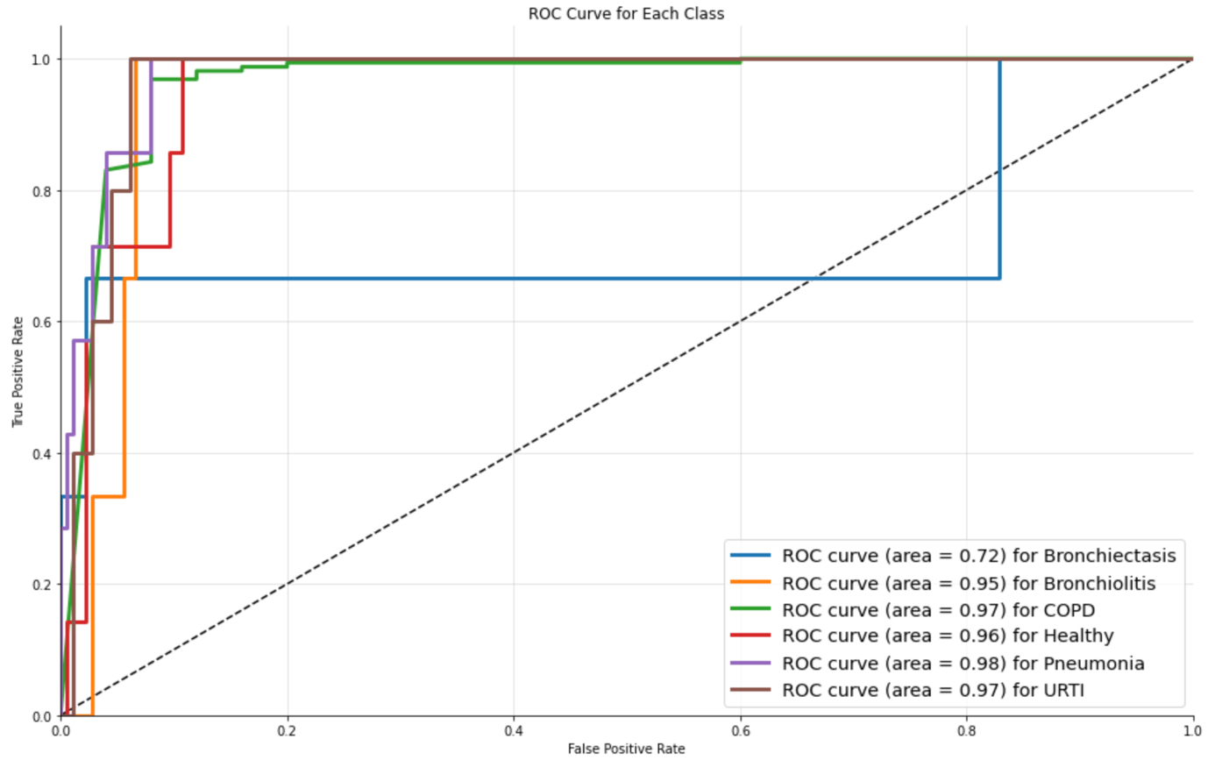

precision recall f1-score support

Bronchiectasis 1.00 0.33 0.50 3

Bronchiolitis 0.00 0.00 0.00 3

COPD 0.92 0.99 0.96 159

Healthy 0.50 0.14 0.22 7

Pneumonia 0.57 0.57 0.57 7

URTI 0.33 0.20 0.25 5

accuracy 0.90 184

macro avg 0.55 0.37 0.42 184

weighted avg 0.86 0.90 0.87 184

Confusion Matrix

[[ 1 0 1 0 1 0]

[ 0 0 2 1 0 0]

[ 0 0 158 0 1 0]

[ 0 0 4 1 0 2]

[ 0 0 3 0 4 0]

[ 0 0 3 0 1 1]]

# Model 14

4 convolution layers with 32, 64, 128 and 256 filters respectively and added dropouts of 20% on each layer. One dense hidden layer with 256 neurons and one output layer with 6 neurons.

Number of Epochs = 125

Training Accuracy: 0.9699863791465759

Testing Accuracy: 0.885869562625885

precision recall f1-score support

Bronchiectasis 1.00 0.33 0.50 3

Bronchiolitis 0.25 0.33 0.29 3

COPD 0.96 0.96 0.96 159

Healthy 0.25 0.14 0.18 7

Pneumonia 0.60 0.86 0.71 7

URTI 0.20 0.20 0.20 5

accuracy 0.89 184

macro avg 0.54 0.47 0.47 184

weighted avg 0.88 0.89 0.88 184

Confusion Matrix

[[ 1 0 1 1 0 0]

[ 0 1 0 1 0 1]

[ 0 0 153 1 4 1]

[ 0 1 3 1 0 2]

[ 0 0 1 0 6 0]

[ 0 2 2 0 0 1]]

# Model 15

4 convolution layers with 64,64, 96 and 96 filters respectively. 6 hidden layers with 256, 128, 64, 32, 16, and 8 neurons respectively with dropouts of 60%, 30%, 15%, 7.5%, 3.75% and 3.25% respectively. One output layer with 3 neurons.

Number of Epochs= 120

Training Accuracy: 0.9709020256996155

Testing Accuracy: 0.8914728760719299

precision recall f1-score support

Chronic 0.91 0.97 0.94 159

Healthy 0.81 0.75 0.78 28

Non Chronic 0.89 0.76 0.82 71

accuracy 0.89 258

macro avg 0.87 0.83 0.85 258

weighted avg 0.89 0.89 0.89 258

Confusion Matrix

[[155 0 4]

[ 4 21 3]

[ 12 5 54]]

# Model 16

4 convolution layers with 64,64, 96 and 96 filters respectively and added dropouts of 20% on each layer. 4 hidden layers with 256, 128, 64 and 32 neurons respectively with dropouts of 60%, 30%, 15% and 7.5% respectively. One output layer with 3 neurons.

Number of Epochs= 120

Training Accuracy: 0.9253152012825012

Testing Accuracy: 0.8798449635505676

precision recall f1-score support

Chronic 0.93 0.97 0.95 159

Healthy 0.62 0.71 0.67 28

Non Chronic 0.88 0.73 0.80 71

accuracy 0.88 258

macro avg 0.81 0.81 0.81 258

weighted avg 0.88 0.88 0.88 258

Confusion Matrix

[[155 2 2]

[ 3 20 5]

[ 9 10 52]]

# Model 17

4 convolution layers with 64,64, 96 and 96 filters respectively and added dropouts of 20% on each layer. 3 hidden layers with 256, 128 and 64 neurons respectively with dropouts of 60% and 30% respectively for first two hidden layers. One output layer with 3 neurons.

Number of Epochs= 120

Training Accuracy: 0.9505334496498108

Testing Accuracy: 0.8643410801887512

precision recall f1-score support

Chronic 0.91 0.96 0.94 159

Healthy 0.70 0.68 0.69 28

Non Chronic 0.81 0.72 0.76 71

accuracy 0.86 258

macro avg 0.81 0.79 0.80 258

weighted avg 0.86 0.86 0.86 258

Confusion Matrix

[[153 1 5]

[ 2 19 7]

[ 13 7 51]]

# Model 18

4 convolution layers with 64,64, 96 and 96 filters respectively and added dropouts of 20% on each layer. 4 hidden layers with 256, 128, 64 and 32 neurons respectively with dropout of 40% after the last hidden layer. One output layer with 3 neurons.

Number of Epochs= 120

Training Accuracy: 0.9243453145027161

Testing Accuracy: 0.8837209343910217

precision recall f1-score support

Chronic 1.00 0.94 0.97 159

Healthy 0.53 0.93 0.68 28

Non Chronic 0.88 0.73 0.80 71

accuracy 0.88 258

macro avg 0.80 0.87 0.82 258

weighted avg 0.92 0.88 0.89 258

Confusion Matrix

[[150 4 5]

[ 0 26 2]

[ 0 19 52]]